

**Asia Pacific College**

***Barangay System***

**Project Team**

***Kamila Lagman  
Christian Ansel Sevilla  
David Warren Arcellana  
Jhonel Deluna***

**Professor**

***Mr. Manuel Sanchez***

**Project Adviser/s**

***Ms. Roselle Gardon  
Mr. Ernesto Boydon***

**Table of Contents**

I. Target Audience – Page 3

II. General Objectives – Page 3

III. Project Plan  
 I. Event table – Page 3  
 II. Use Case Diagram – Page 5  
 I. Use case full description   
 III. Data Flow Diagram – Page 9  
 I. DFD Fragments  
 II. Level 0  
 III. Level 1  
 VI. Entity Relationship Diagram – Page 12  
 V. Activity Diagram – Page 13  
 VI. Data Dictionary – Page 13

VII. Softcopies of signed status report – Page 15  
 VIII. Gantt chart – Page 16  
 VIII. Screenshot of proposed system – Page 17

**Target Audience**

Our focused users will be the barangay citizens and officials. Helping them in managing and securing their own records.

**General Objectives**

Create organized and secured information details for the barangay citizen to provide fast and accurate transactions. Help lessen complications such as information redundancy caused by repetitive registration and avoid missing data thus leading to successful document processes.

Educate the citizens by providing them with appropriate content of information and giving them easy access to this information.

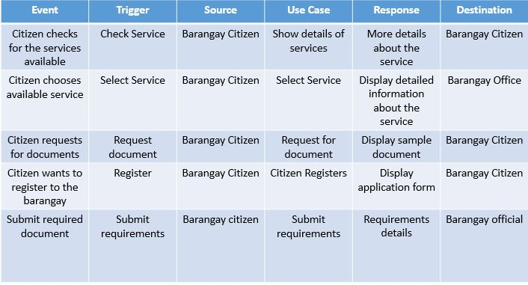**Barangay Citizen**

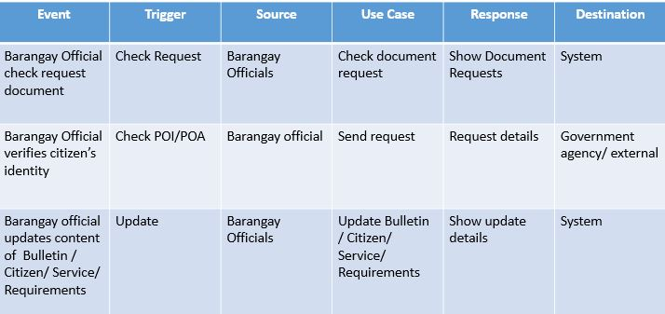**Barangay Official**

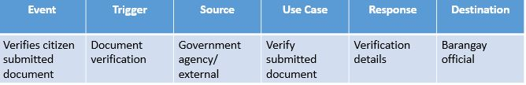**Government Agency/External**

**Use Case Diagram**

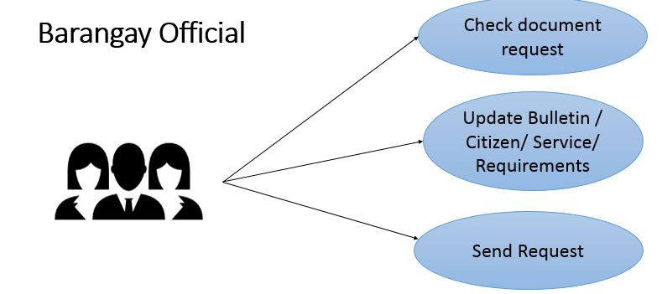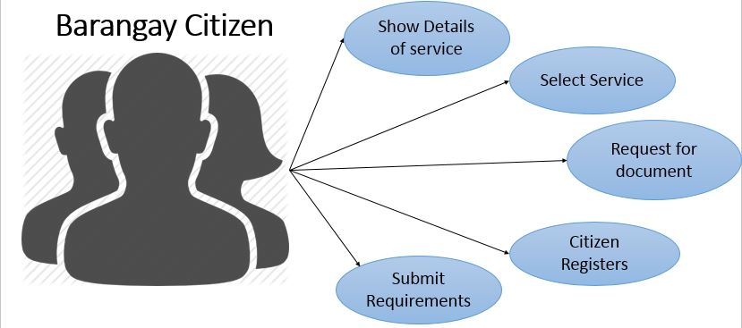Barangay CitizenBarangay Official

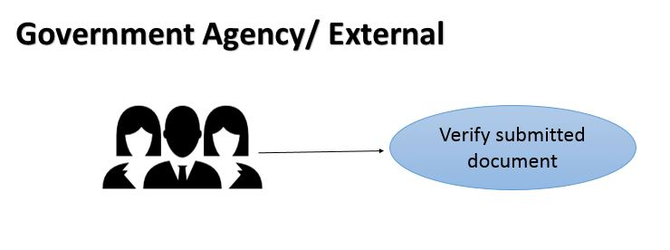Government Agency/External

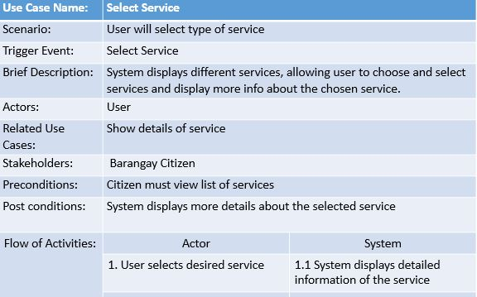**Use Case full description**

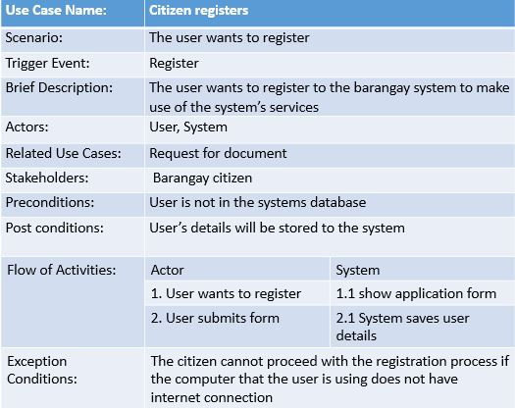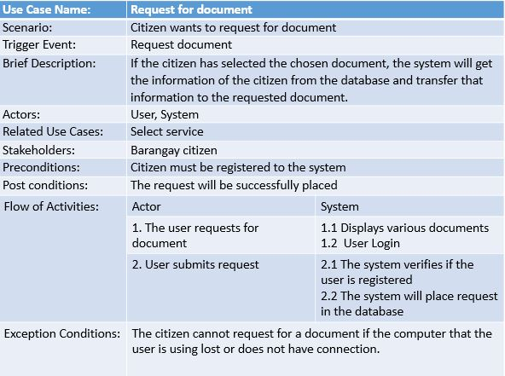

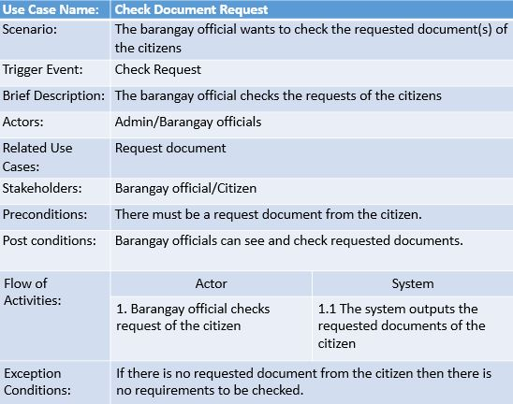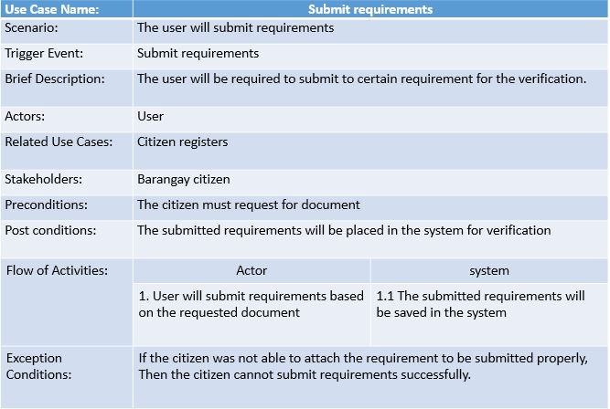

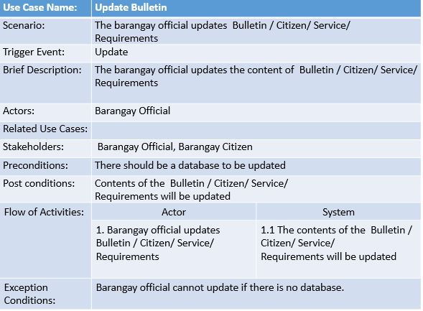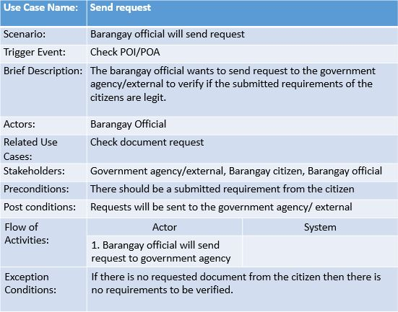

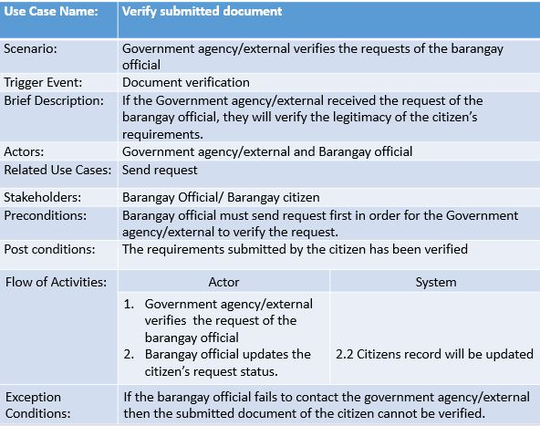

**DFD Fragments**

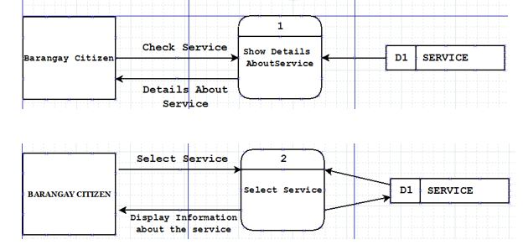

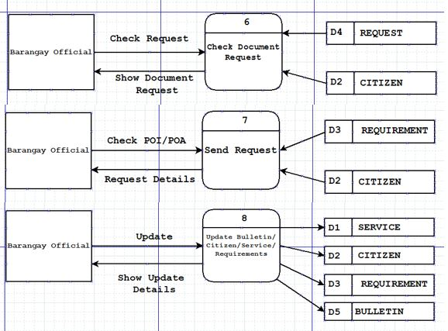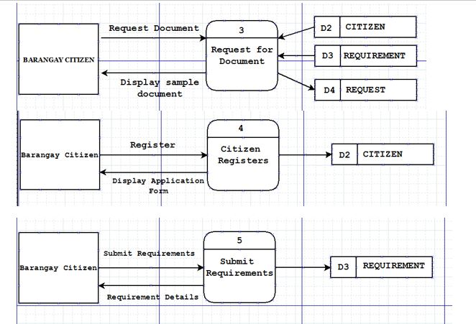

**Level 0**

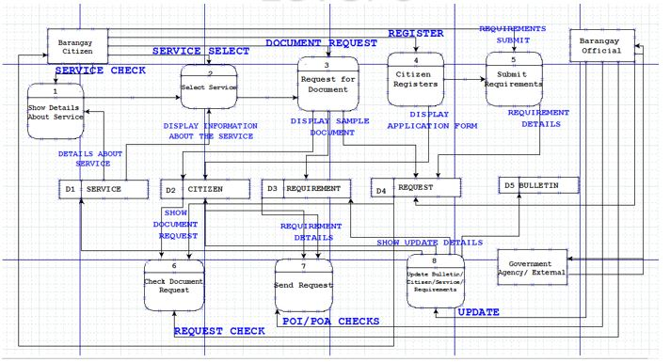

**Level 1**

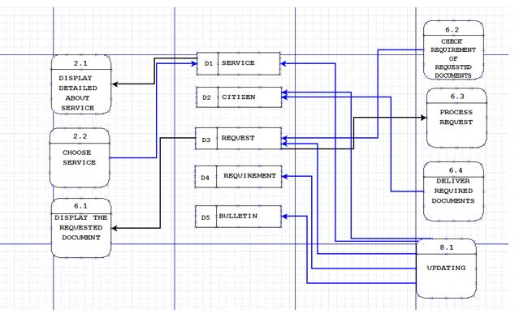

**Context Diagram**

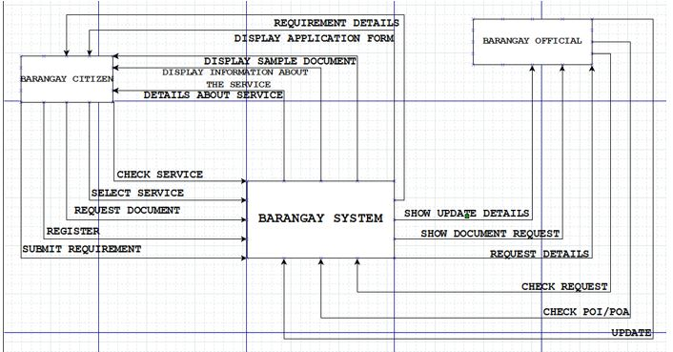

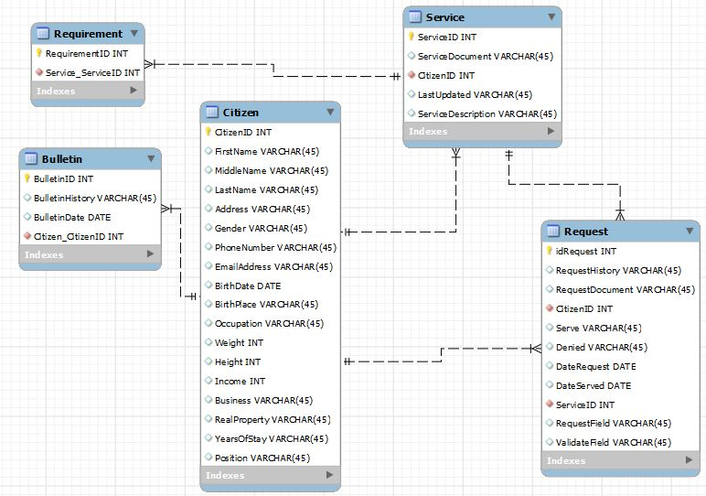**Entity Relationship Diagram**

**Activity Diagram**

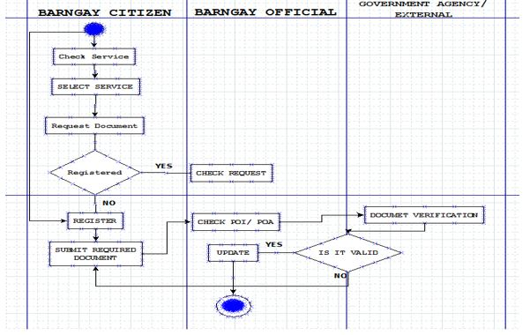

**Data Dictionary**

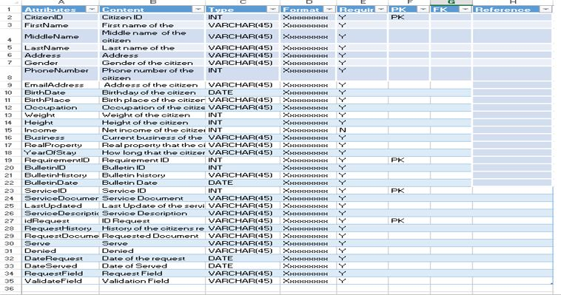

**Signed status report**

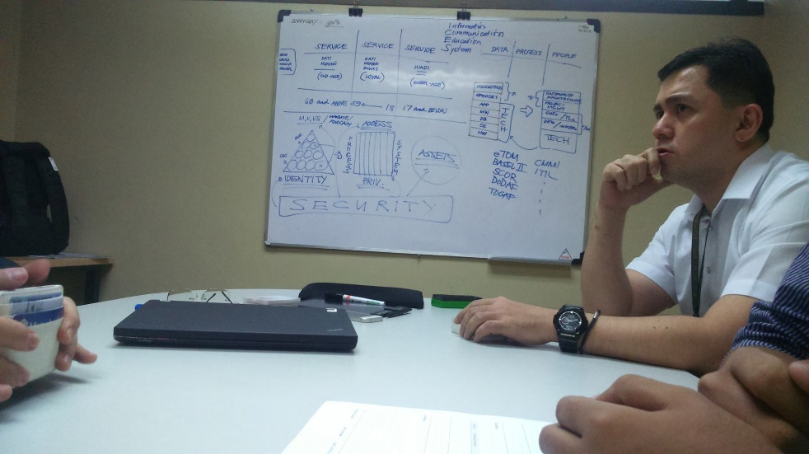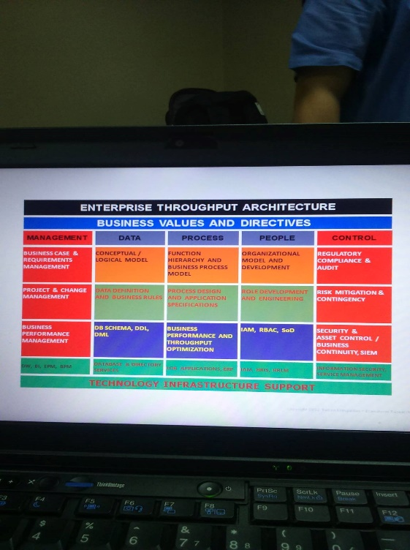

Second Meeting (Teleconference)

-Sir Abner

-warren

-kamila

Business Rules

-Barangay

-Barangay Services

-Services to Constituents

-Residence

Information Gather

* First Rule

-People who will be resident in barangay.

-to start Information Gathering you must use the Basic Questions.

Business Value

(1)Fairness

-All eligible voters should be 18 and above.

-All eligible voters should only vote ones.

(2)Accuracy

-It should be recorded as intended.

-should be counted.

**Gantt Chart**

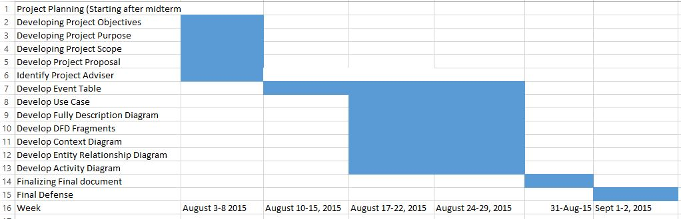

**Screenshots of proposed system**

